

# Motorola Edge 20 Fusion 5G

## Type of device: Mobile

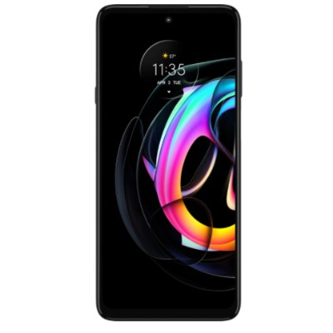

Actual Display Size : 6.7 inches

Button Type : Touchscreen

Operating System : Android

Version Number : Android 11

Network Capability : 3G,4G,5G

Year of Release : 2021

Average Price : $449 as of 10 12 2021

## Accessibility Features:

### Cognitive

* Additional Instructions
* Copy and Paste
* GPS
* Photo Telephone List
* Screen Timeout Disabled
* Simple Instructions
* Simple Reminders
* Simplify Display

Voice Notes

### Hearing Impairment and Deaf

* Allows for sign language communication
* Bluetooth or Wi-Fi
* Closed Captioning
* Front Facing Camera
* Hearing Aid Microphone Coupling
* Hearing Aid Telecoil Coupling
* Text Messaging/SMS
* Vibrating Alerts - Adjustable
* Video Communications - Two-way

Visual Alerts - Incoming Calls

### Vision

* Battery Alert - Audible
* Bluetooth or Wi-Fi
* Braille Display Support
* Brightness Adjustable
* Dictation / Speech-to-Text
* High Contrast Mode
* Personalised Shortcuts
* Power Cue
* Screen Magnifier
* Screen Reader
* Text Size Adjustable
* Text Style Adjustable
* Voice Control /Personal Assistant

Voiced Menus

### Speech

* Allows for sign language communication
* Bluetooth or Wi-Fi
* Messaging Options - Email
* Messaging Options - IM
* Messaging Options - MMS
* Predictive Text

SMS Personalisation and Reuse

### Physical

* Automatic Answer
* Bluetooth or Wi-Fi
* Dictation / Speech-to-Text
* Gesture Based Navigation
* Headset - plug connected
* Predictive Text
* Speaker-phone option
* Stylus or Prosthetic Device support
* Switch control option
* Voice Control / Personal Assistant
* Voice Recognition for Accessing Features

Voice Recognition for Dialling

## How and where to get it from?

You can buy this phone from [Kogan](https://www.kogan.com/au/shop/category/smartphones/?q=Motorola+Edge+20+fusion+5G&page=1), [Dicksmith](https://www.dicksmith.com.au/da/shop/category/smartphones/?q=Motorola+Edge+20+fusion+5G&page=1), [Officeworks](https://www.officeworks.com.au/shop/officeworks/search?q=Motorola%20Edge%2020%20fusion%205G&view=grid&page=1&sortBy=bestmatch), [Woolworths](https://www.woolworths.com.au/shop/productdetails/1073831060?cq_src=GOOGLE&cq_cmp=Everyday-Market%7C%7C%20Big%20W%20%7C%7C_S6674_BAU_Shopping_Smart_EVM-0001&cq_con=BIGW&cq_term=PRODUCT_GROUP&cq_net=u&cq_plt=gp&cq_med=71700000088648836&cq_gclid=EAIaIQobChMIk4W3057Y9AIVRpNmAh31wwoeEAQYByABEgIJu_D_BwE&cmpid=smsm:ds:GOOGLE:Everyday-Market%7C%7C%20Big%20W%20%7C%7C_S6674_BAU_Shopping_Smart_EVM-0001:PRODUCT_GROUP&gclid=EAIaIQobChMIk4W3057Y9AIVRpNmAh31wwoeEAQYByABEgIJu_D_BwE&gclsrc=aw.ds), [JB-HI FI](https://www.jbhifi.com.au/search?query=Motorola%20Edge%2020%20fusion%205G&page=1), [Vodafone](https://www.vodafone.com.au/mobile-phones/motorola-moto-edge20-fusion-5g?capacity=128GB&color=Electric%20Graphite&contractTerm=36), and other retailers.

## More information is available on:

[Motorola Edge 20 Fusion 5G Web Page](https://www.motorola.com.au/smartphones-motorola-edge-20-fusion/p)

[Motorola Edge 20 Fusion 5G User Guide (PDF Download)](https://help.motorola.com/hc/7125/11/pdf/help-motorola-edge-20-fusion-11-global-en-us.pdf)